**VIRTUAL MO USE USING AI**

***project submitted in partial fulfillment of the requirements for the award of the degree of***

**BACHELOR OF TECHNOLOGY**

**IN**

**DATA SCIENCE**

**BY**

**E. PAVANI (22C95A6706)**

**B .KARUNAKAR (22C95A6708)**

**K. VARUN (21C91A6722)**

**T.SATHVIK REDDY (21C91A6739)**

**Under The Esteemed Guidance of**

**Mr. B RAVINDAR REDDY**

**proffesor**



**DEPARTMENT OF DATA SCIENCE**

**HOLY MARY INSTITUTE OF TECHNOLOGY & SCIENCE**

***(Approved by AICTE New Delhi, Permanently Affiliated to JNTUHyderabad, Accredited by NAAC with ‘A’ Grade)***

**Bogaram(V), Keesara (M), Medchal District -501 301.**

**2023 - 2024**

# HOLY MARY INSTITUTE OF TECHNOLOGY & SCIENCE

***(Approved by AICTE New Delhi, Permanently Affiliated to JNTU Hyderabad, Accredited by NAAC with ‘A’ Grade)***

**Bogaram (V), Keesara (M), Medchal Dist-501301**

## DEPARTMENT OF CSE-DATA SCIENCE



# CERTIFICATE

This is to certify that the major project entitled “VIRTUAL MOUSE USING AI” is being submitted by E.PAVANI (22C95A6706), B.KARUNAKAR (22C95A6708), K.VARUN(21C91A6722), T.SATHVIK REDDY (21C91A6739) in Partial fulfillment of the academic requirements for the award of the degree of Bachelor of Technology in “COMPUTER SCIENCE ANDENGINEERING” HOLY MARY INSTITUTE OF TECHNOLOGY &SCIENCE, JNTU Hyderabad during the year 2016-2017.

**INTERNAL GUIDE HEAD OF THE DEPARTMENT**

Mr. B RAVINDAR REDD Dr. / Mr. S. SRINIVAS

Professor Professor

Dept. of Computer Science & Engineering.Dept. of Computer Science & Engineering

## ACKNOWLEDGEMENT

The satisfaction and euphoria that accompany the successful completion of any task would be incomplete without the mention of the people who made it possible, who’s constant guidance and encouragement crowns all effort with success.

I take this opportunity to express my profound gratitude and deep regards to My Guide **Dr. Srinivas**, Dept. of Computer Science &Engineering, Holy Mary Institute of Technology & Science for his / her exemplary guidance, monitoring and constant encouragement throughout the project work.

My special thanks to **Dr. S. Srinivas, Head of the Department**, Dept. of Data Science, Holy Mary Institute of Technology & Science who has given an immense support throughout the course of the project.

I also thank to **Dr. P. Bhaskara Reddy,** the **honorable Director** of my college Holy Mary Institute of Technology & Science for providing me the opportunity to carry out this work.

I also thank to **Dr. JBV Subramanyam,** the **honorable Principal** of my college Holy Mary Institute of Technology & Science for providing me the opportunity to carry out this work.

At the outset, I express my deep sense of gratitude to the beloved **Chairman Dr. A. Vara Prasad Reddy & Secretary Dr. A. VijayaSarada Reddy** of **Holy Mary Institute of Technology & Science**, for giving me the opportunity to complete my course ofwork.

I am obliged to **staff members** of Holy Mary Institute of Technology & Science for the valuable information provided by them in their respective fields. I am grateful for their cooperation during the period of my assignment.

Last but not the least I thank **ALMIGHTY** and My **Parents**, and **Friends** for their constant encouragement without which this assignment would not be possible.

E.PAVANI (22C95A6706)

B.KARUNAKAR (22C95A6708)

K.VARUN (21C91A6722) T.SATHVIK REDDY (21C91A6739)

**DECLARATION**

This is to certify that the work reported in the present projecttitled **“VIRTUAL MOUSE USING AI”** is a record of work done by me in the Department of Computer Science &Engineering, Holy Mary Institute of Technology and Science.

No part of the thesis is copied from books/journals/internet and whenever the portion is taken, the same has been duly referred in the text the reported are based on the project work done entirely by me not copied from any other source.

**E.PAVANI (22C95A6706)**

**B.KARUNAKAR (22C95A6708)**

**K.VARUN (21C91A6722)**

**T.SATHVIK REDDY (21C91A6739)**

**CONTENTS:**

**CONTENT NAME PAGE NO**

**Abstract** 1

**List of Figures** 2

**List of Screens** 2

## 1.INTRODUCTION 3

## 

1.1 Motivation of work 3

1.2 Existing System 4

1.3 Disadavantages of Existing System 4

1.4 Proposed System 7

1.5 Advantages of Proposed System 7

**2.LITERATURE SURVEY 8**

## 3.SYSTEM ANALYSIS 9

3.1 Feasibility Study 9

3.2 Modules 10

3.3 Modules Description 12

## 4.SYSTEM DESIGN 14

4.1 System Architecture 15

4.2 System Requirements 17

4.3 UML Diagrams 18-21

## 

## 5.IMPLEMENTATION 22

5.2 Output Design 22-25

5.5 Sample Coding26

**7.RESULTS 27**

**8.CONCLUSION 28**

**9.BIBILIOGR 29**

**ABSTRACT**

The Al Virtual Mouse uses computer vision techniques to track hand movements and translates them into cursor movements on the screen. The system is designed to be intuitive and user-friendly, allowing users to interact with their computer without the need for a physical mouse. The virtual mouse is developed using Python and OpenCV libraries. The project includes the implementation of various image processing algorithms, such as hand segmentation, feature extraction, and classification. Moreover, it is robust to various lighting conditions, backgrounds, and hand sizes. The developed system provides an alternative to conventional mouse devices, particularly for individuals with disabilities or those who prefer a more natural way of interacting with their computers. The target of this project is the invention of something new in the world of technology that helps an individual work without the help of a physical mouse. It will save the user money and time. Real-time images will be continuously collected by the Virtual Mouse color program and put through a number of filters and conversion.

## 

**LIST OF FIGURES**

**Figure No. Name of the Figure Page No.**

1 SYSTEM DESIGN 15

2 SYSTEM ARCHITECTURE 17

3 SYSTEM DESIGN(2) 19

4 CLASSS DIAGRAM 20

5 USE CASE DIAGRAM 21

6 SEQUENCE DIAGRAM 22

**LIST OF SCREENS**

**Figure No.**  **Name of the Figure Page No.**

7 SCREEN MATCHING 22

8 MOUSE FUNCTION 23

9 LEFT BUTTON CLICK 24

10 RIGHT BUTTON CLICK 25

## 1. INTRODUCTION

While using a wireless or a Bluetooth mouse, some devices such as the mouse, the dongle to connect to the PC, and also, a battery to power the mouse to operate are used to make it work. This project proposes an AI virtual mouse system that makes use of the hand gestures and hand tip detection for performing mouse functions in the computer using computer vision. In computer jargon, a computer mouse is a directing device that recognizes two-dimensional motions in respect to a surface. This movement is converted into the movement of the cursor on a display in order to manipulate the GUI, or Graphical User Interface, on a computer platform. It's difficult to fathom living in our high-tech day without computers. Another of the greatest innovations ever made by humans is the computer. Virtual mouse using AI is a technology that allows users to control the mouse cursor on a computer using gestures or voice commands, instead of a physical mouse. It uses artificial intelligence algorithms to interpret these inputs and translate them into mouse movements and actions on the screen. This can be especially useful for individuals with physical disabilities or for situations where using a physical mouse is not possible or convenient. It's an innovative way to interact with computers and opens up new possibilities for accessibility and control.

### 1.1 MOTIVATION OF WORK

Considering the current scenario of the ongoing crisis of the COVID-19 pandemic, it is not safe to use the devices by touching them because it may result in a possible situation of spread of the virus by touching the devices. The proposed AI virtual mouse can be used to overcome these problems since hand gesture and hand tip detection is used to control the PC mouse functions by using a webcam or a built-in camera.

### 1.2 EXISTING SYSTEM

As of my last knowledge update in January 2022, there were several existing systems and technologies related to virtual mice powered by AI. Please note that the landscape of technology evolves rapidly, and new developments may have occurred since then. Here are some examples of existing systems as of my last update:

1. Google Auto ML Vision: While not a virtual mouse in the traditional sense, Google's Auto ML Vision allows developers to build custom image recognition models. These models could be utilized in applications where visual inputs are interpreted as commands, resembling a virtual mouse system.

2. Windows 10 Eye Control : Microsoft's Eye Control feature in Windows 10 enables users to control the mouse and keyboard using eye movements. This system relies on AI and computer vision to interpret eye gaze as input.

3. Open AI's Dactyl: Open AI's Dactyl is a robotic hand trained using reinforcement learning. While not a virtual mouse for traditional computing, it demonstrates the application of AI in learning and performing dexterous tasks, which can be relevant to robotic interfaces.

## 1.3 DISADAVANTAGES OF EXISTING SYTEM

As of my last knowledge update in January 2022, existing systems of virtual mice powered by AI may have certain disadvantages or limitations. It's important to note that technology evolves rapidly, and advancements may have occurred since then. Here are some potential disadvantages associated with existing systems as of the last update:

**1. Accuracy and Precision:**

Existing virtual mice systems may face challenges in achieving high accuracy and precision, especially in tasks that require fine-grained control. This can result in

suboptimal user experiences, particularly in applications that demand precise interactions.

**2. Learning Curve:**

- Users may experience a learning curve when adapting to new AI-powered virtual mouse systems, particularly if the system relies on novel input methods or gestures. Users may need time to become proficient in utilizing the system effectively.

**3. Dependency on Visual Input:**

Systems that heavily rely on computer vision for gesture recognition or eye tracking may struggle in low-light conditions or environments with poor visibility. This dependency on visual input can limit the system's performance in certain scenarios.

**4. Limited Customization:** Some existing systems may offer limited customization options for users. A lack of flexibility in adapting the virtual mouse's behavior to individual preferences and needs could be a drawback.

**5. Security Concerns**: Systems that collect and analyze user data for personalized learning may raise privacy and security concerns. Ensuring the protection of user data and maintaining compliance with privacy regulations is crucial.

6. **Resource Intensiveness:** AI algorithms can be computationally intensive, leading to high resource utilization. This may affect the system's performance on devices with limited processing power, potentially causing delays or slowdowns.

7. **Lack of Standardization**: In the absence of industry-wide standards, different virtual mouse systems may have varying user interfaces, gestures, or control mechanisms. Lack of standardization can lead to confusion and hinder user adoption.

8. **Assistive Technology Challenges**: Virtual mice designed for assistive technology may not fully address the diverse needs of individuals with disabilities. Challenges may include limited support for specific disabilities or difficulty in providing intuitive control for certain tasks.

9. **Integration with Legacy Systems**: Compatibility issues may arise when integrating AI-powered virtual mice with older or legacy systems. Ensuring seamless integration across various platforms and software applications can be a complex task.

10. **Cost of Implementation**: The implementation and deployment of advanced AI systems, including virtual mice, can involve significant costs. This may pose a barrier to widespread adoption, especially in resource-constrained environments.

**1.4 PROPOSED SYSYSTEM**

* The proposed system of AI Virtual Mouse is designed to help reduce the transmission of bacteria.
* The proposed system gives the procedural approach of how to manipulate the mouse using hand gestures.
* Hand gesture and hand tip detection by using computer vision is used as a Human Computer Interaction(HCI)

**1.5 ADVANTAGES OF PROPOSED SYSTEM**

A proposed system of a virtual mouse powered by AI offers several advantages that aim to enhance user interactions, accessibility, and adaptability. Here are some potential advantages of such a system1.

### 1.Adaptive Learning: The virtual mouse can adapt and learn from user behaviors over time, providing a personalized experience. This leads to increased efficiency and a more user-centric interaction.

### 2.Multiple Input Modalities: Supporting gestures, voice commands, and potentially other input modalities provides users with diverse ways to interact with the virtual mouse, catering to individual preferences and accessibility needs.

### 3. Context Awareness: The system can be aware of the context in which it is being used, adjusting its behavior accordingly. This enhances the virtual mouse's ability to respond intelligently to different tasks and applications.

### 4. Assistive Technology Features: The proposed system can include features specifically designed for individuals with disabilities, making it more inclusive and accessible. This can include support for eye-tracking, switch-based input, or other assistive technologies.

### 

### 2. LITERATURE SURVEY :

A literature survey on virtual mice powered by AI involves reviewing relevant academic and research publications, conference papers, and articles to gain insights into the current state of the field. Here's a general overview of the literature survey on virtual mouse systems with AI components:

1. Title: “Human-Computer Interaction Using Virtual Mouse: A Comprehensive Review” This paper provides a comprehensive review of virtual mouse systems incorporating AI technologies. It covers the evolution of virtual mice, various AI algorithms employed, and their impact on human-computer interaction.

2. Title: “Machine Learning Approaches in Virtual Mouse Systems: A Comparative Analysis”The paper presents a comparative analysis of different machine learning approaches used in virtual mouse systems. It evaluates the performance of algorithms in terms of accuracy, efficiency, and adaptability.

3. Title: “Gesture-Controlled Virtual Mice: A Survey of Techniques and Applications” Focusing on gesture-controlled virtual mice, this survey explores the state-of-the-art techniques for gesture recognition in AI-powered systems. It discusses applications across industries, including gaming, healthcare, and robotics.

4. Title: “Advancements in Assistive Technologies: AI-Driven Virtual Mice for People with Disabilities” This literature review concentrates on the integration of AI in virtual mice to enhance assistive technologies for individuals with disabilities. It assesses the impact on accessibility and user experience.

5. Title: “Real-Time Responsiveness in Virtual Mouse Systems: A Review of Challenges and Solutions” Examining the challenges associated with achieving real-time responsiveness in virtual mouse systems, this paper reviews existing solutions and proposes novel approaches to enhance system performance

when conducting a literature survey, it's important to search academic databases such as IEEE Xplore , PubMed, ACM Digital Library, and others for the most recent and relevant research papers. Additionally, conference proceedings from major HCI (Human-Computer Interaction) conferences and journals in computer science can provide valuable insights into the latest developments in virtual mouse systems with AI component

#### 3 .SYSTEM ANALYSIS

#### 3.1 FEASIBILITY STUDY

#### A feasibility study for a virtual mouse system powered by AI involves assessing the technical, economic, legal, operational, and scheduling aspects of the proposed system. Here's an overview of each feasibility aspect:

#### Technical Feasibility: Objective: Assess whether the proposed virtual mouse system is technically viable.

#### Considerations: Availability of AI technologies: Ensure that the necessary AI algorithms and technologies are mature and available for implementation.

#### Hardware and software requirements: Evaluate whether the required hardware and software components are accessible and can support the system's functionality.

#### Integration with existing systems: Examine how well the virtual mouse system can integrate with existing software and hardware environments.

#### Economic Feasibility: Determine the cost-effectiveness of developing and implementing the virtual mouse system.

#### Considerations Development costs: Estimate the costs associated with developing the AI algorithms, computer vision modules, and other components.

#### Operational costs: Evaluate ongoing expenses related to maintenance, updates, and support.

#### Potential return on investment (ROI): Analyze whether the benefits, such as improved user experience and productivity gains, justify the costs.

#### Legal Feasibility: Identify and address legal and regulatory considerations associated with the virtual mouse system.

#### Considerations:Data privacy and security: Ensure compliance with data protection regulations and implement measures to safeguard user data.

#### Intellectual property: Assess potential legal issues related to the use of specific algorithms or technologies.

#### Accessibility compliance: Verify that the system adheres to accessibility standards and regulations, especially if targeting users with disabilities.

#### 4. Operational Feasibility: Evaluate how well the virtual mouse system aligns with the organization's operational processes and goals.

#### Considerations: User acceptance: Assess whether end-users are likely to adopt and adapt to the new virtual mouse system.

#### Training requirements: Identify the training needs for users and support staff to effectively operate and maintain the system.

#### Workflow integration: Ensure that the virtual mouse system fits seamlessly into existing workflows.

#### 3.2 MODULES

The development of a virtual mouse system powered by AI typically involves the integration of several modules, each responsible for specific functions and features. Here are common modules that could be part of a virtual mouse system on AI:

* **User Interface Module**: Provides the graphical interface for users to interact with the virtual mouse.
* Display of virtual mouse pointer and interface elements.
* Feedback mechanisms for user interactions.
* **AI Algorithm Module**: Implements the core AI algorithms for learning, prediction, and adaptation.
* Machine learning models for user behavior prediction.
* Reinforcement learning for continuous improvement.

Decision-making algorithms for adaptive behavior.

* **Computer Vision Module**: Processes visual input from cameras or sensors to interpret gestures or other visual cues.
* Gesture recognition algorithms.
* Eye-tracking capabilities.
* Facial expression analysis.
* **Natural Language Processing (NLP) Module**: Enables the virtual mouse to understand and respond to voice commands.
* Speech recognition algorithms.
* Command parsing and interpretation.
* -Integration with virtual assistant functionalities.
* **Gesture Recognition Module**: Focuses on recognizing and interpreting user gestures for controlling the virtual mouse.
* Training models for specific gestures.
* Real-time gesture tracking.
* Multi-modal gesture recognition (e.g., hand movements, finger gestures).
* **User Profile and Preferences Module**: Manages individual user profiles, preferences, and customization settings.
* Storage of user-specific data.
* Learning and adaptation based on user behavior.
* Customizable settings for sensitivity, speed, etc.

These modules work collaboratively to create a virtual mouse system that is adaptive, user-friendly, and capable of providing a seamless human-computer interaction experience powered by AI. The specific features and functionalities within each module can be further tailored based on the goals and requirements of the virtual mouse system.

* **Manufacturer Module:**

The manufacture module for a virtual mouse system powered by AI involves the production and assembly of the physical components, as well as the integration of the software modules into a cohesive product. Here are the key steps and considerations for the manufacture module:

The manufacture module involves a combination of hardware and software integration, quality control, logistics planning, and compliance to bring the virtual mouse system to market. Collaboration between hardware engineers, software developers, and manufacturing experts is crucial to ensure a seamless and high-quality production process.

#### 3.3 MODULES DESCRIPTION

The modules of a virtual mouse system powered by AI can be described in detail to understand their specific functionalities. Each module contributes to the overall capabilities of the virtual mouse, enhancing user interaction, adaptability, and performance. Here are detailed descriptions of the key modules:

1. User Interface Module-Description: The User Interface Module is responsible for creating the graphical interface that users interact with. It displays the virtual mouse pointer and other relevant interface elements. This module includes visual feedback mechanisms to inform users of their actions.

2. AI Algorithm Module-Description: The AI Algorithm Module forms the core intelligence of the virtual mouse. It incorporates machine learning algorithms, such as deep learning or reinforcement learning, to understand user behavior, predict actions, and adapt over time. This module continuously refines the virtual mouse's capabilities based on user interactions.

3. Computer Vision Module-Description:The Computer Vision Module processes visual input from cameras or sensors. It interprets gestures, eye movements, and facial expressions, converting them into commands for the virtual mouse. This module is crucial for enabling hands-free control and enhancing the system's responsiveness.

4. **Natural Language Processing (NLP) Module-Description: The NLP Module allows users to control the virtual mouse through voice commands. It includes speech recognition algorithms to convert spoken words into actionable commands. This module expands the input modalities, providing an additional way for users to interact with the system.

These modules work together to create a sophisticated virtual mouse system that leverages AI technologies to provide a personalized, adaptive, and user-friendly interaction experience. Each module plays a crucial role in enhancing different aspects of the system's functionality and usability.

### 4. SYSTEM DESIGN

* A system diagram is a visualization of a system as a flow-chart-like diagram.
* We can discover problems and shortcomings of the design the diagram represents.

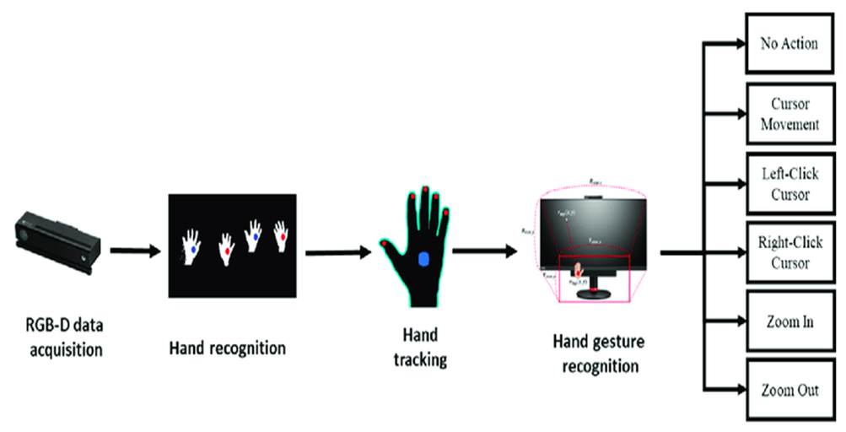

**FIG[1] SYSTEM DESIGN**

#### 4.1 SYSTEM ARCHITECTURE

#### In a virtual mouse project, the system architecture typically consists of several components working together. One common architecture involves the following elements:

#### 1. Input Module: This module captures user inputs, such as gestures or voice commands, and converts them into a format that can be understood by the system.

#### 2. Gesture/Voice Recognition: This component uses machine learning or pattern recognition algorithms to interpret the captured inputs and recognize the intended gestures or commands.

#### 3. Cursor Control: Once the gestures or commands are recognized, this module translates them into corresponding cursor movements, such as moving the cursor up, down, left, or right.

#### 4. Click and Scroll Actions: This component handles actions like left-click, right-click, double-click, and scrolling, based on user inputs.

#### 5. User Interface: The virtual mouse system typically includes a user interface that displays the virtual cursor and provides feedback to the user.

#### 6. Integration with Operating System: The virtual mouse system needs to communicate with the underlying operating system to control the cursor movements and perform mouse-related actions.

#### 7. Accessibility Features: Virtual mouse projects often include accessibility features, such as adjustable sensitivity, customizable gestures, or voice commands, to cater to different user needs.

#### 

#### FIG[2] SYSTEM ARCHITECTURE

**4.2 SYSTEM REQUIREMENTS**

**SOFTWARE REQUIREMENTS:**

* Python (3.7.4)
* IDE (Pycharm)
* OpenCV
* Mediapipe
* Autopy
* Math
* Enum
* Pyautogui
* Screen Brightness control
* Ctypes

**HARDWARE REQUIREMENT:**

• RAM (4 GB)

• Free space (1 GB)

• Web Cam (5 MP)

• Hard Disk (400 GB)

• Processor (Intel I3)

**4.3 UML DIAGRAMS**

**4.3.1 SYSTEM DESIGN DIAGRAM**

• A system diagram is a visualization of a system as a flow-chart-like diagram.

• We can discover problems and shortcomings of the design the diagram represents.

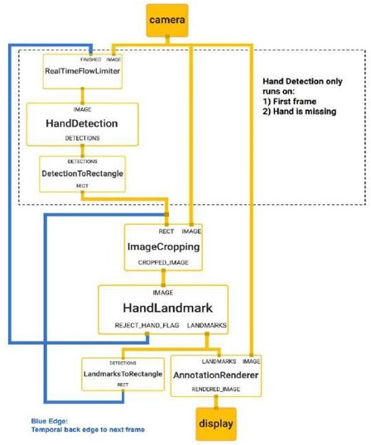

**FIG[3]: SYSTEM DESIGN DIAGRAM**

**4.3.2 CLASS DIAGRAM**

• It contains the classes involved and shows the connections between the various classes.

• Class diagram includes classes, which further has a class label or name, attributes of the class and the operations or functions performed by the class.

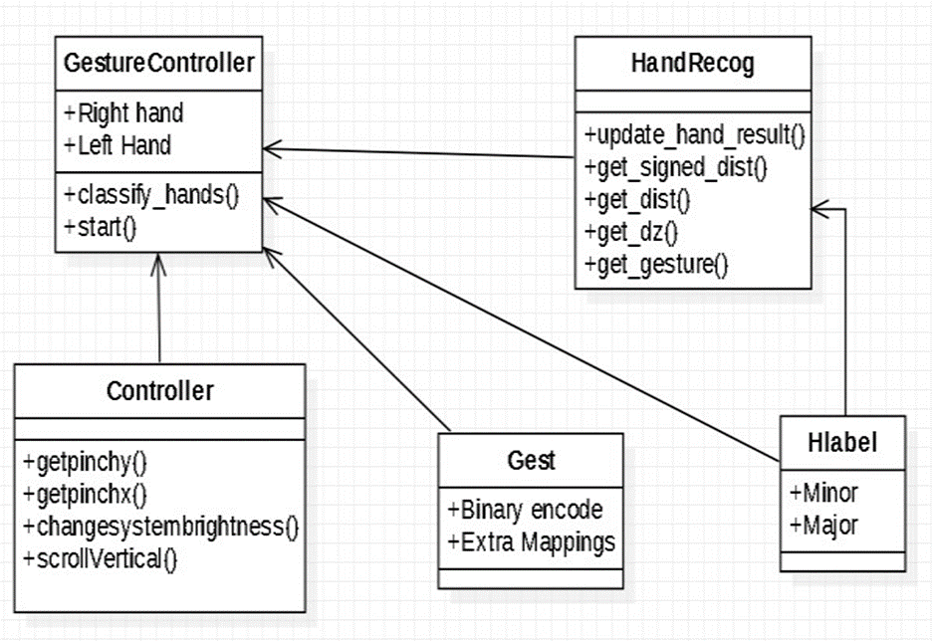

**FIG[4]:CLASS DIAGRAM**

**4.3.3 USE CASE DIAGRAM**

* Use case diagram consists of use cases and actors.
* The main purpose is to show the interaction between the use cases and the actor.
* It intends to represent the system requirement from user’s perspective.
* The use cases are the functions that are to be performed in the module.

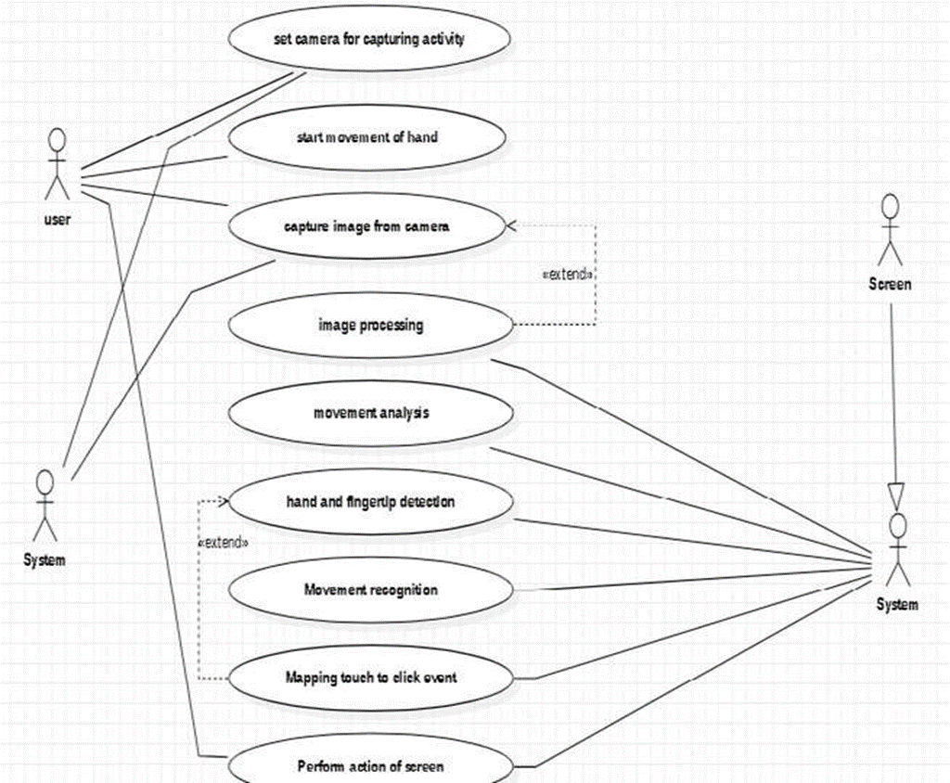

**FIG[5]:USE CASE DIAGRAM**

**4.3.4 SEQUENCE DIAGRAM**

* It shows the sequence of the steps that are carried out throughout the process of execution.
* It involves lifelines or life time of a process that shows the duration for which the process is alive while the steps are taking place in a sequential manner.
* Sequence diagram specifies the order in which the various steps are executed.

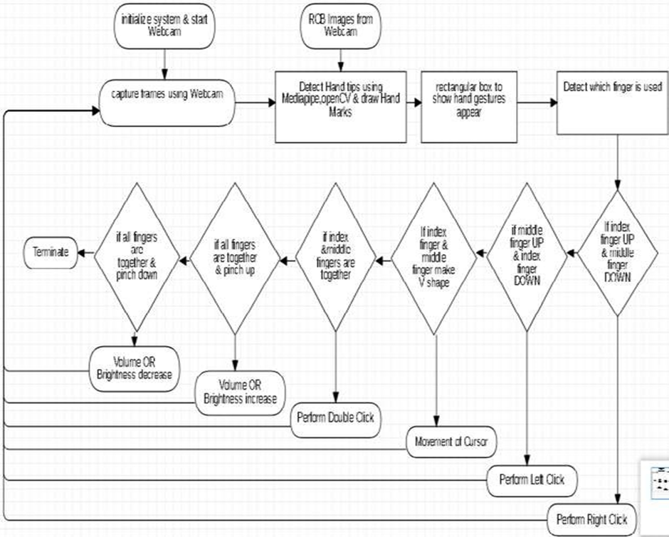

**FIG[6]:SEQUENCE DIAGRAM**

**5.IMPLEMENTATION**

**5.1 OUTPUT DESIGN:**

## (Virtual Screen Matching) Rectangular Region for Moving through the Window

The AI virtual mouse system makes use of the transformational algorithm, and it converts the coordinates of the fingertip from the webcam screen to the computer window full screen for controlling the mouse. When the hands are detected and when we find which finger is up for performing the specific mouse function, a rectangular box is drawn with respect to the computer window in the webcam region where we move throughout the window using the mouse cursor.

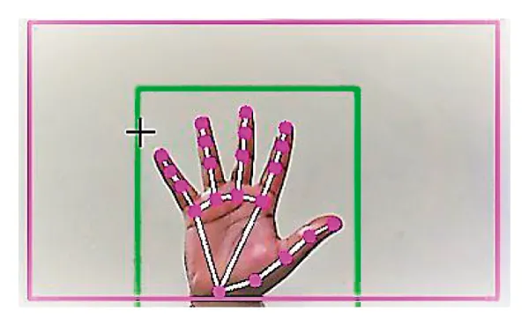

**FIG[7]:SCREEN MATCHING**

## Detecting Which Finger Is Up and Performing the Particular Mouse Function

In this stage, we are detecting which finger is up using the tip Id of the respective finger that we found using the MediaPipe and the respective coordinates of the fingers that are up, and according to that, the particular mouse function is performed.

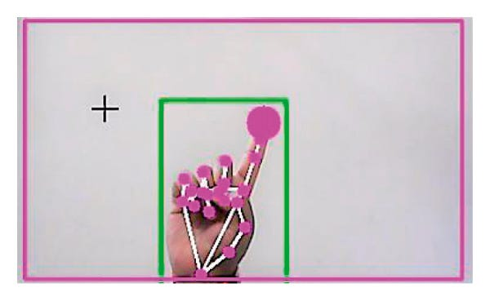

**FIG[8]:MOUSE FUNCTION**

## Left Button Click

If both the index finger with tip Id = 1 and the thumb finger with tip Id = 0 are up and the distance between the two fingers is lesser than 30px, the computer is made to perform the left mouse button click using the pinout Python package.

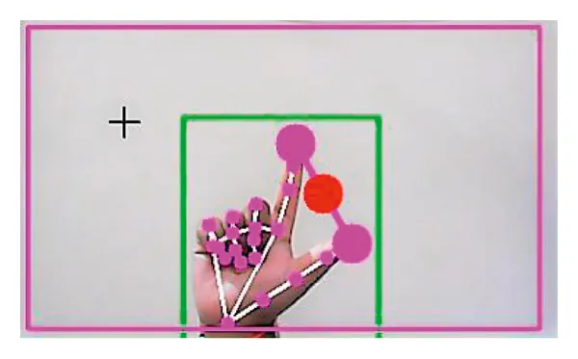

**FIG[9]:LEFT BUTTON CLICK**

## Right Button Click

If both the index finger with tip Id = 1 and the middle finger with tip Id = 2 are up and the distance between the two fingers is lesser than 40 px, the computer is made to perform the right mouse button click using the input Python package

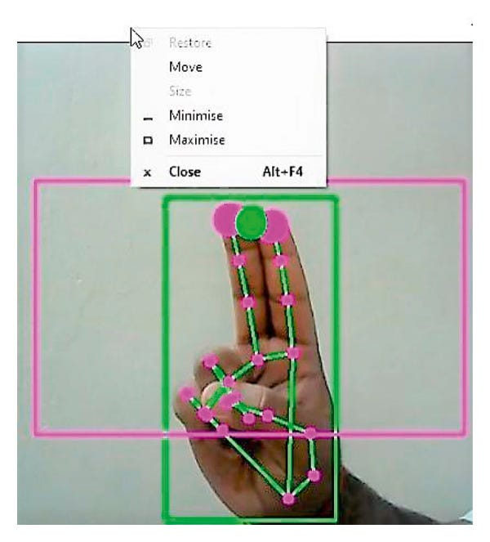

**FIG[10]:RIGHT BUTTON CLICK**

**5.2 SAMPLE CODING**

import cv2

import mediapipe as mp

import pyautogui

cap = cv2.VideoCapture(0)

hand_detector = mp.solutions.hands.Hands()

drawing_utils = mp.solutions.drawing_utils

screen_width, screen_height = pyautogui.size()

index_y = 0

while True:

_, frame = cap.read()

frame = cv2.flip(frame, 1)

frame_height, frame_width, _ = frame.shape

rgb_frame = cv2.cvtColor(frame, cv2.COLOR_BGR2RGB)

output = hand_detector.process(rgb_frame)

hands = output.multi_hand_landmarks

if hands:

for hand in hands:

drawing_utils.draw_landmarks(frame, hand)

landmarks = hand.landmark

for id, landmark in enumerate(landmarks):

x = int(landmark.x*frame_width)

y = int(landmark.y*frame_height)

if id == 8:

cv2.circle(img=frame, center=(x,y), radius=10, color=(0, 255, 255))

index_x = screen_width/frame_width*x

index_y = screen_height/frame_height*y

if id == 4:

cv2.circle(img=frame, center=(x,y), radius=10, color=(0, 255, 255))

thumb_x = screen_width/frame_width*x

thumb_y = screen_height/frame_height*y

print('outside', abs(index_y - thumb_y))

if abs(index_y - thumb_y) < 20:

pyautogui.click()

pyautogui.sleep(1)

elif abs(index_y - thumb_y) < 100:

pyautogui.moveTo(index_x, index_y)

cv2.imshow('Virtual Mouse', frame)

cv2.waitKey(1)

**6. RESULTS**

The proposed system controls the functions of mouse pointer by detecting red, and perform the mouse functions such as left click, dragging, cursor movement, and the file transfer between two systems in a same network. This method detect the red colour objects for the mouse control. The user uses the red colour obects on their finger tip for the better performance. When the number of contours are two, then it perform the simple mouse movement action. Otherwise, when the number of contour is one then it perform the left click. This system also supports the simple file transfer between two or more systems in the same network connection. The left side of the computer’s screen act as a communication channel between the systems. ie, the file which is to be copy should drag and drop on the left side of the computer’s screen. Then the dropped file will be copied to the destination or the reciever system. This system is mainly aimed to reduce the use of hardware components attatched with the computer. Although the application can be run in a ordinary computer having a web camera. but ideally it requires having at least 2MP frontal camera with at least Pentium processor and at least 256 MB RAM

**7. CONCLUSION**

The main objective of the AI virtual mouse system is to control the mouse cursor functions by using the hand gestures instead of using a physical mouse. The proposed system can be achieved by using a webcam or a built-in camera which detects the hand gestures and hand tip and processes these frames to perform the particular mouse functions. From the results of the model, we can come to a conclusion that the proposed AI virtual mouse system has performed very well and has a greater accuracy compared to the existing models and also the model overcomes most of the limitations of the existing systems with a smooth margin.

**8.BIBLIOGRAPHY**

[1]D.-S. Tran, N.-H. Ho, H.-J. Yang, S.-H. Kim, and G. S. Lee, “Real-time virtual mouse system using RGB-D images and fingertip detection,” Multimedia Tools and Applications Multimedia Tools and Applications, vol. 80, no. 7, pp. 10473–10490 (2021).

[2] Shibly, K.H., Dey, S.K., Islam, M.A., Showrav, S.I.: Design and development of hand gesture based virtual mouse. In: 2019 1st International Conference on Advances in Science, Engineering and Robotics Technology (ICASERT). pp. 1–5. IEEE (2019).

[3] Abhilash S S, Lisho Thomas, NWCC, Virtual Mouse Using Hand Gesture. International Research Journal of Engineering and Technology (IRJET) (2018).

[4] Haria A, Subramanian A, Asokkumar N, Poddar S, Nayak JS Hand gesture recognition for human computer interaction. Procedia Comput Sci 115:367–374 (2017).